I first cloned the assignment on my git bash and made the commands step by step:

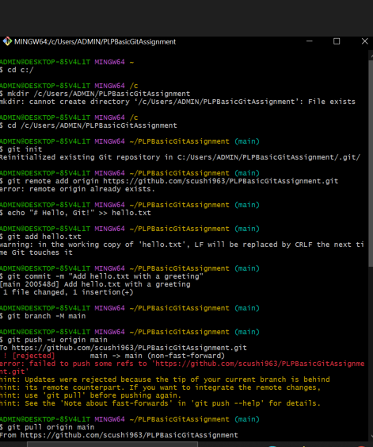

I found an error when I made the ‘git push’ command.

I then ran the ‘git pull” command to resolve any merging conflicts and started the git cloning again

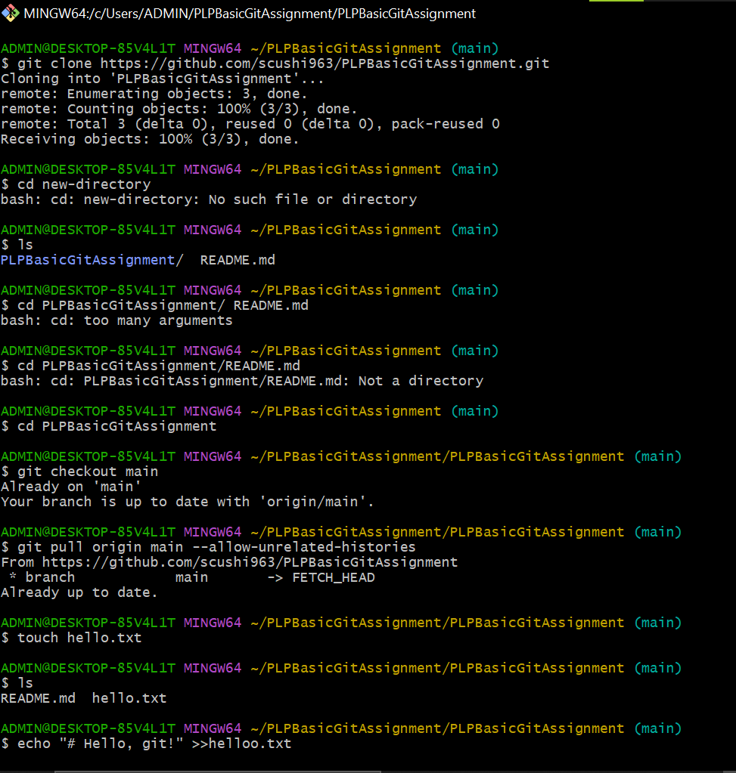

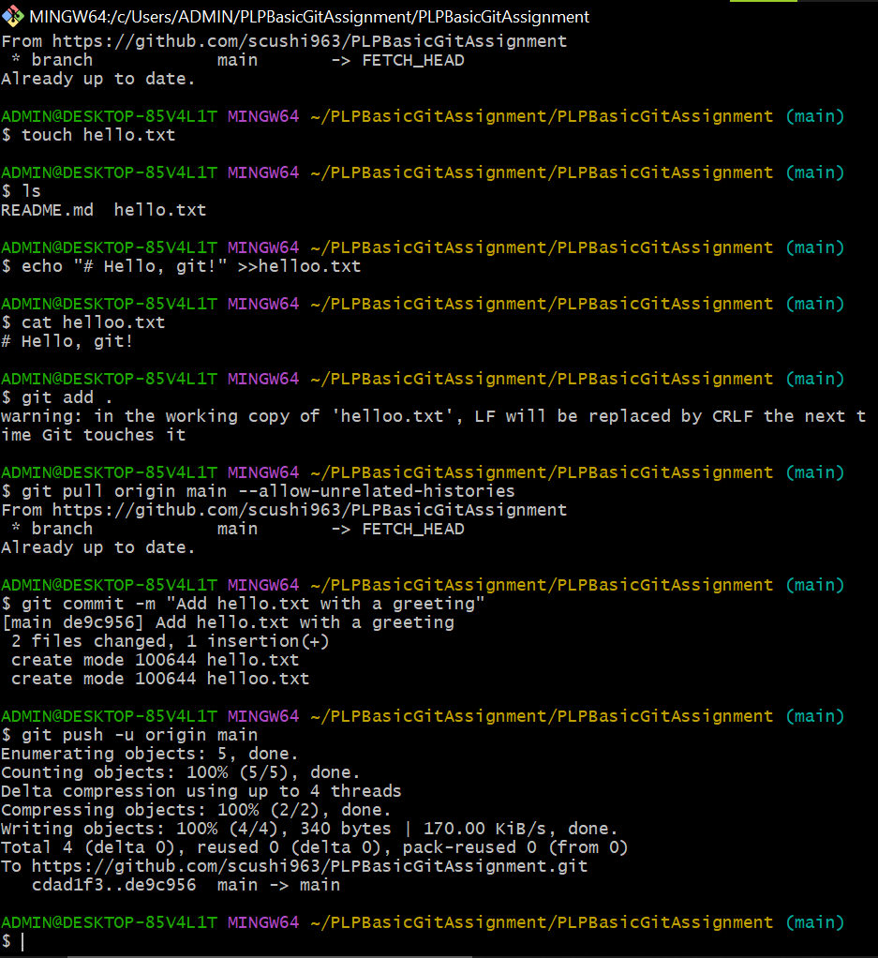

Here I found out that I had two ‘hello.txt’ files in my repository and I had to remove one.

